
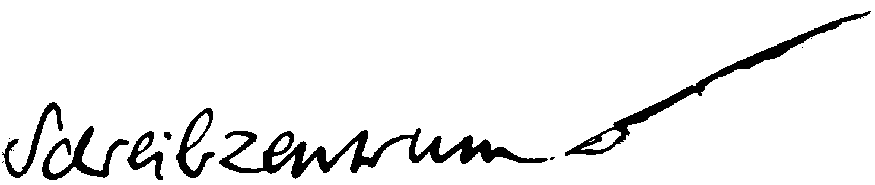

4th Conference of the European
Association for the Teaching of Academic Writing

“Teaching Academic Writing across and in the Disciplines”

June 30 – July, 2, 2007
Ruhr-Universität Bochum
Germany

Conference Registration Form

Deadlines for registration for
➔ contributors: March 15, 2007
➔ participants: April 30, 2007

Please e-mail the completed form to eataw2007@schreibzentrum.de

In case there is no e-mail access, please post or fax the order form to:

Schreibzentrum der Ruhr Universität Bochum
Universitätsstraße 150
Gebäude GB, Etage 5, Raum 151
44780 Bochum
Germany

Fax: +49 (234) 32-05104

Please complete all fields. Thank you.

PERSONAL DETAILS

Title: Mr / Ms / Dr. / Professor
First name:
Last name:

Address:
ZIP or Postal Code:
State / Province:
City:
Country:
Telephone with country and area code:
Fax with country and area code:
E-mail:

INSTITUTION / EMPLOYER / AFFILIATION

Name:
Department:
Job Title / Position:

Address:
ZIP or Postal Code:
State / Province:
City:
Country:

PAYMENT

The conference fee will be 120.- Euro per person. It has to be payed until the deadlines to:

Gabriela Ruhmann
Sparkasse Bochum
Bank Code No. (BLZ): 430 500 01
Account No. (Kto. Nr.): 0033407487

Purpose (Verwendungszweck): EATAW 2007 + THE NAME OF THE PARTICIPANT
IBAN: DE 64430500010033407487
BIC (Swift): WELADED1BOC

Confirmation: I acknowledge that this registration can not be finalized until the organisation team has received full payment of the 120 €.

Alteration or cancellations of orders should be made in writing and addressed to:

Schreibzentrum der Ruhr Universität Bochum
Universitätsstraße 150
Gebäude GB, Etage 5, Raum 151
44780 Bochum
Germany

Fax: +49 (234) 32-05104
eataw2007@schreibzentrum.de

Information for the catering

I am a vegetarian

Other?

Please note: This is not the personal account of Gabriela Ruhmann ☺! Baptizing it the organiser’s name is only for facilitating bureaucracy. All entries will be made transparent to the EATAW board.

